GBL/GBL - How to assist the users if they face issues with Login Denied error message in HRA?
Problem:
How to assist the users if they face issues with Login Denied error message in HRA
Solution:
Before connecting, AnyConnect check for the installed Anti-Virus and firewall on the user’s laptop. The following error messages can popup while trying to connect to Cisco AnyConnect if the user’s machine does not meet the security requirements.
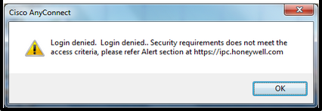

If the user reports Login denied error in HRA

- Validate that Windows Firewall is enabled
  - Start -> Control Panel -> Windows Firewall

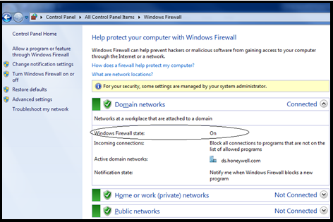
  - If not enabled, enable it (turn it on) and try to connect again
- Make sure the Antivirus is running
  - Check if McAfee ENS/Threat Prevention is running on the user’s Machine:
  - Right click McAfee in system tray -> McAfee Endpoint Security

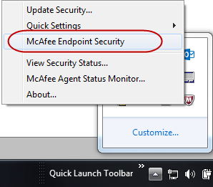

  - When McAfee ENS is working properly you will see Threat Prevention: Enabled, Firewall: Disabled, and Web Control Enabled

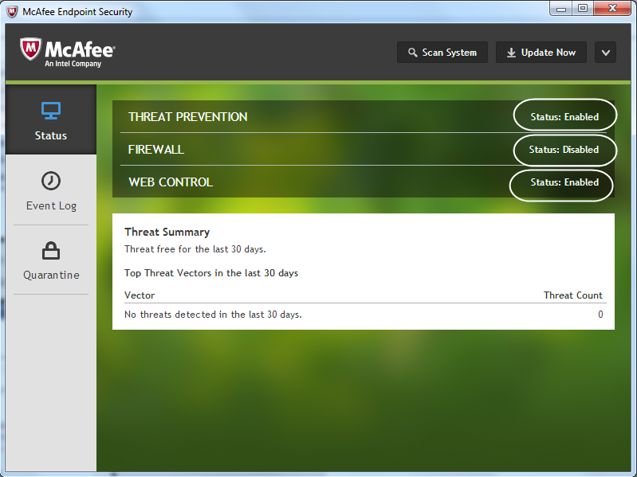
- Check if the McAfee ENS DAT file is updated within last 30 days on User’s Machine by selecting the down-arrow on the ENS Console, and selecting “About”. The DAR version is directly over the DAT date.

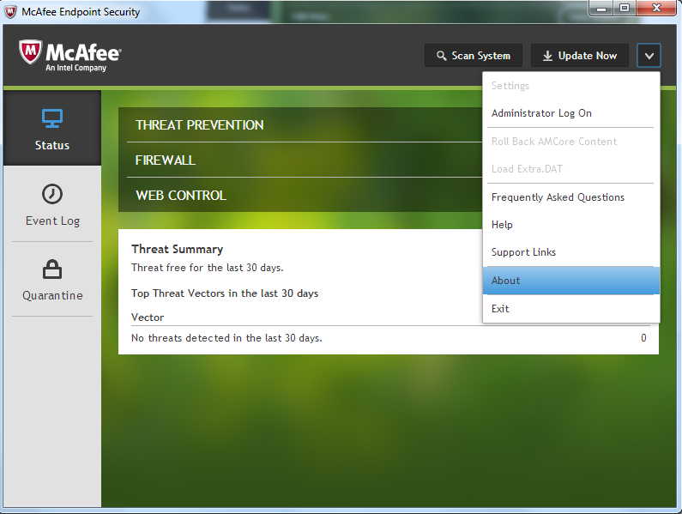
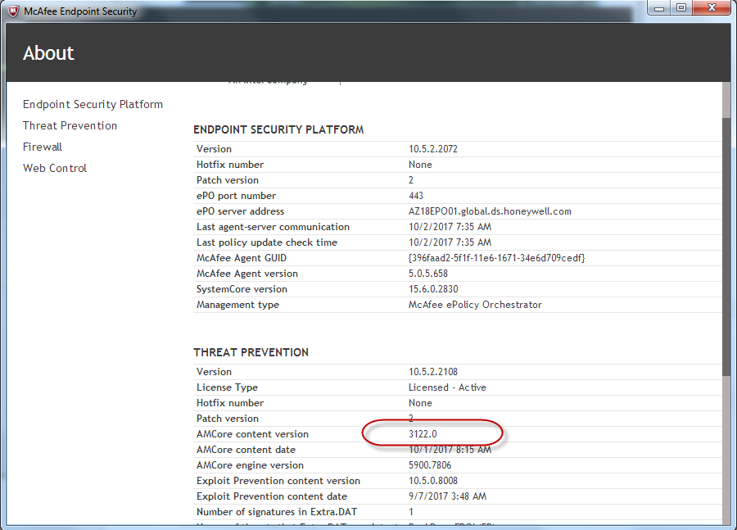

- If not updated within the last 30 days, please try updating by clicking the Update Now button on the ENS Console.

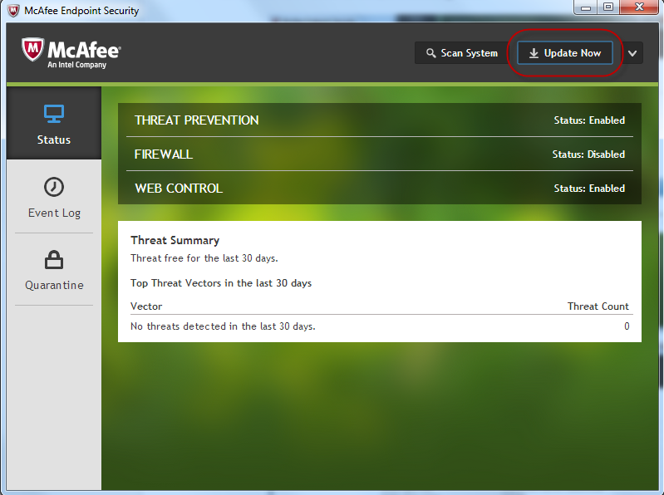

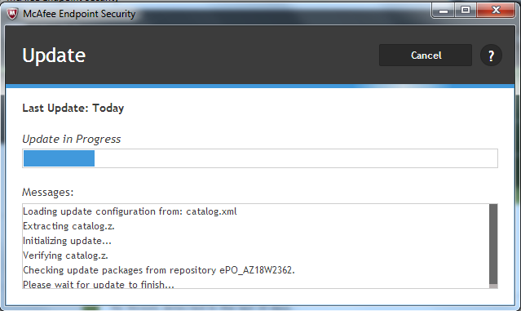

- If not getting updated or update is failing, then the ENS installation may be in progress or has possibly become corrupt
- If ENS is in the process of upgrading or installing please see KBA00047504: GBL/GBL - Endpoint Security Installation Process
- If ENS is broken then it will need to be uninstalled - See KBA00047503: GBL/GBL - How to Uninstall and Reinstall McAfee Endpoint Security (ENS) for instruction on how to resolve this issue
- After the installation is complete or repaired go back to step #4 above to attempt an update again. Update Now may need to be ran several times.
- An update can also be performed using the McAfee Agent Status Monitor – available from the McAfee Icon context menu
- Now Check if user is able to get connected to VPN

If still issue persists, please call your Regional Service Desk.

